
Dementia Action Week Report – 19th – 25th May 2025

Background

Dementia Action Week is a national campaign set up by the Alzheimer’s Society. In Gloucestershire, we support this week and have our own Integrated Care System (ICS) Project Group to decide on what we do in Gloucestershire; our partners include, Mindsong, Age UK, Alzheimer’s Society, Gloucestershire Libraries, Gloucestershire Health and Care NHS Foundation Trust, Managing Memory Together – IES Team, Integrated Care Board, Active Gloucestershire, Gloucestershire Carers Hub, Gloucestershire Care Providers Association, Gloucestershire Dementia Action Alliance and the locality groups.

The Dementia Action Week Project Group monthly meetings started in January 2024 which moved to fortnightly meetings in the run up to the week. Matt Blackman (Communications Manager) lead on the comms plan with consistent branding to use across the ICS.

The theme agreed by the group and also guidance from experts with lived experience for 2025 was “Start the conversation, make a difference” wanting to focus on communication and importance of having conversations.

Events in Dementia Action Week

Saturday 17th May 2025 - Stroud Farmers Market

- Approximately 25 – 30 meaningful conversations:
- One employee of the NHS – Mum just been diagnosed in SBV – unhappy SBV finishing, not happy with letter. Unaware of IES and Carer / family support
- Lots of people with a diagnosis not knowing where to get family / carer support
- Couple from Forest of Dean – supports 2x dementia charities – one Research – three out of four parents died with dementia – one left brain to brain bank – didn’t know about Bristol Brain Bank – Details given.
- New OT from Stroud – been to IES session, wants to come to more. Unsure of when she can refer people to IES, doesn’t want to “step on Later Lifes” toes! Interested in doing more Dementia Education, unaware of DETS.
- Couple from Stroud – moved Dad into the County from Kent – several awful experiences – Kent – delivery of news from memory services awful – hospital admission awful – wasn’t aware of dementia services in Glos. Current care home being “awkward” re LPoA. Filled in RESPECT – only encouraged to answer DNAR
- 2x people interested in the Dementia Action Alliance in Stroud – details provided there and then.
- 3x conversations about parents “in denial”- wanting advice on what to do – each conversation anasognosia talked about.
- 2x people wanting advice on “moving their person with dementia” to live near them or into a care home.
- 2x referrals to Bookcase Scenario video clip!
- 2x people going to self-refer to Mindsong
- 4x children / relatives “caring for” a person with dementia who are living out of County.

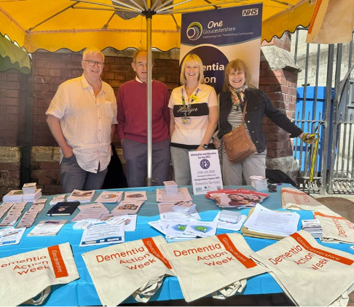

Sunday 18th May 2025 – Hindu Health Event

- Dementia Awareness Session – Between 30 and 40 people in attendance, people kept coming in during the presentation!
- Lady wanting to access education – Connected to the Dementia Education Training Strategy
- 3x Separate conversations with three different members of the same family, all with the same struggles and challenges! Denial, Driving, Depression!
- Connection made with Barnwood Trust re the Culturally Diverse Dementia Network – referred to Steve to join the CDDN meetings
- Connection made with Sue Ryder (Beverley Grimster) – wants to be more connected and informed of IES
- Lions Bottles Feedback – people like them!!!
- Approximately 10 meaningful conversations – all within the Common Themes below.

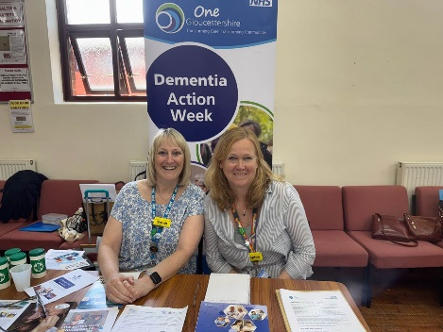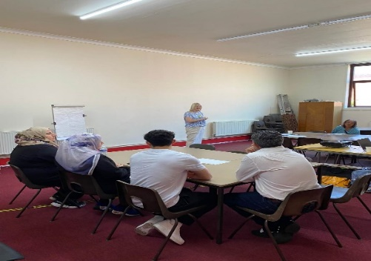

Monday 19th May 2025 – Newent Library Age UK drop in session
Joined up with Age UK at their Newent Library drop in session. Low foot fall, but chatted to one lady and her poor experience of her husband and the care he has received since he was diagnosed with dementia. Support offered / provided.

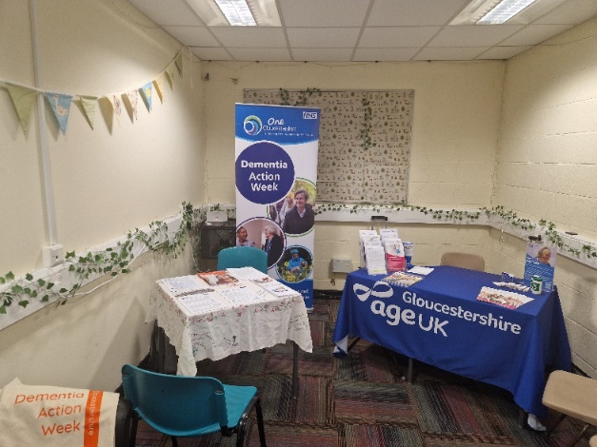

Tuesday 20th May 2025 – Cirencester Livestock Market

- Man worried about his memory – survey given. Advice, Support and Leaflets given, together with the 0800 numbers and IES details
- Lady who we had been speaking to on Facebook came to specifically see us. Very long chat, has a diagnosis of MCI – bag with survey given, lot of stuff written down for her, and names on leaflets for the various people who support her. Memory is VERY poor. Reassured, and contact details for IES given, including names etc.
- Lady came to specifically see us as she is concerned for her Mum. Problems with care home which she feels is not checking physical health, but focusing on her dementia. Advice given, and 0800 number.
- Lady from Churn project attended specifically to see us to reconnect – arrangements to go and see the lady and update and explain services we provide.
- Footfall was poor, not the market that was expected.
- We only had the 3x conversations mentioned above.
- A handful of individuals came in to the blue bus wanting BP checks or COVID Jabs as this was their experience and expectations from previous visits.

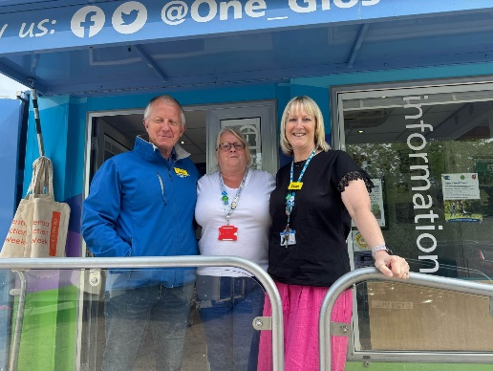

Tuesday 20th May 2025 – Coop, Bouton on the Water
We were at the Coop on Bourton with members of the North Cotswolds Dementia Action Group. Great to chat to people in north Cotswolds about dementia and also many tourists! Session led by members of the north cots dementia action alliance.

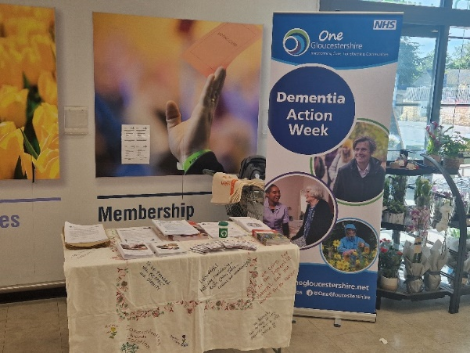

Tuesday 20th May 2025 – Longfields

- Longfields linked to the new Stroud Dementia Action Alliance
- One lady not aware of IES and the Sessions, referral made, dates sent, interested in online support group too
- 3x members of staff specifically came to speak to us worried about parents / relatives – information given
- Volunteer receptionist wanting to know more about the service, and how she can support everyone she volunteers with – Sarah following up
- New Carer Member of Staff – invited to shadow our IES sessions – dates sent
- Still interested in supporting YOD development of services.

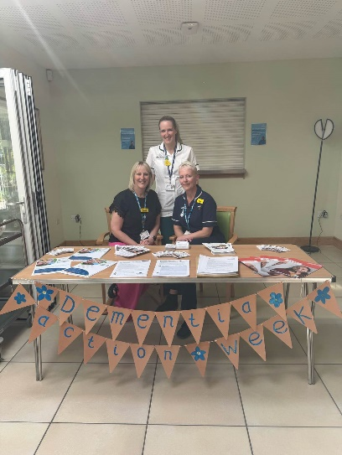

Wednesday 21st May 2025 – ICB / GCC open staff event
An open session for staff working cross the ICB / GCC – great opportunity to remind / update people on what services are available but also form connections with those people as well. People attended from both a professional and personal perspective, so was able to provide tailor support to those personal affected by a dementia.

Wednesday 21st May 2025 – Tewkesbury Market

- Had approximately 10 – 15 meaningful conversations
- Follow up support after a TWNS diagnosis – non-existent

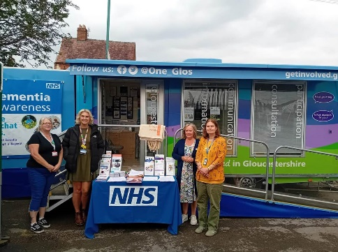

Wednesday 21st May 2025 – GL11

- Councillors from Berkeley – would like Dementia Awareness – given them details and they will contact us when ready.
- Councillors from Berkeley – DAA going to be doing some work with them regarding their new building
- Local Care home to GL11 – not aware of Dementia Education Team and the Dementia Lead and Link Worker Certificate – connected to DETS
- Long conversation with friend of lady with dementia (also present). Mum is very much in denial – has a diagnosis – details given re IES and encouraged to attend sessions and call.
- Lady from Vale Hospital – not aware of the scope of MMTs work and offer post diagnosis.
- Volunteer Manager for GL11 would like dementia education for him and his volunteers – he says he has seen a “greater need to support people with dementia in the community” – details given he will make contact to arrange.
- Lady from Library – developed Chance to Cat Boxes – also a carer for Mum who lives 200 miles away, who is living with dementia – she would like to attend Carers Sessions to understand the diagnosis more.
- Home Instead Cheltenham and Cotswolds – interested in Dementia Education – details given – also wants to be connected to local DAA.

Wednesday 21st May 2025 - Cotswolds Radio:
Steve and members of the North Cots DAA were live on Cotswolds Radio, which was good fun and they played songs that had a memory theme throughout the programme, and we were able to speak to listeners about dementia, how to reduce your risk, how to get a diagnosis and highlight what services are there to support.

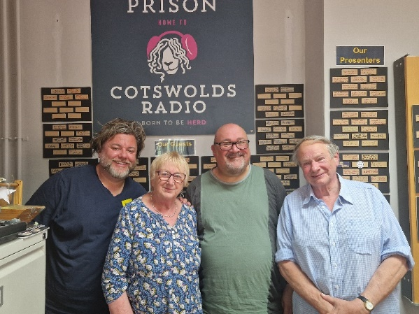

Thursday 22nd May 2025 – Gloucestershire Academy of Music:
We were at the Gloucestershire Academy of Music event that was organised by the Gloucester Dementia Action Alliance, where we had the Major and Deputy Major attended. We also had a talk by Jennifer Bute on her experiences of living well with dementia and also had a presentation on how best to support people living with a dementia which was very well received. Great amount of people attended this open day, which was fab!
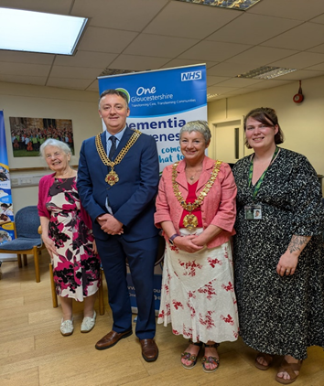
Friday 23rd May 2025 – Stroud DAA Inaugral Meeting

- Fantastic Turn out
- Can send you the full report if you wish
- People signed up there and then to support the development of an Alliance
- Lots of Key people already involved

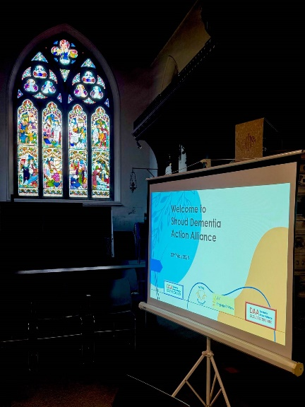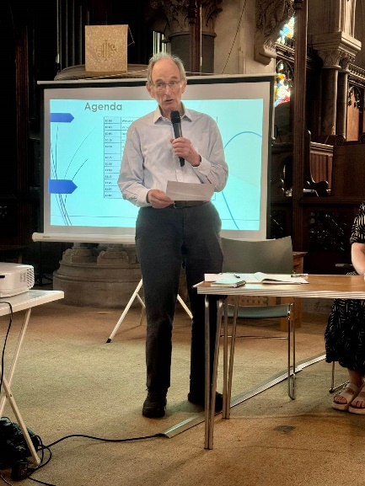
Friday 23rd May 2025 – Gloucester Farmers Market

A warm day out at Gloucester Farmers Market, engaged with many members of the public and provide information and guidance and support as needed. Footfall was down on last year, but useful conversations were had.

Friday 23rd May 2025 – Arkell Centre Nailsworth

- A really lovely setting
- Great cake
- About 20 turned up – inclusive not dementia specific
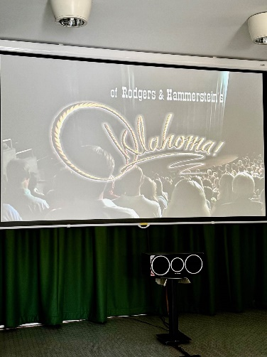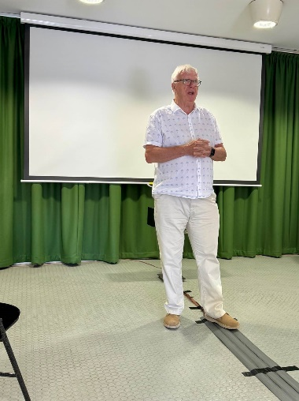

Sunday 25th May – The Suffolks Sunday Market, Cheltenham

The team were at the Cheltenham Market, which was a very vibrant event and the back garden of the Lillian Faithful had been opened for the public, which BBQ, drinks and a fabulous choice of foods! Lots of engagement with the public about dementia and supported with some vital conversations with some who needed more urgent support.
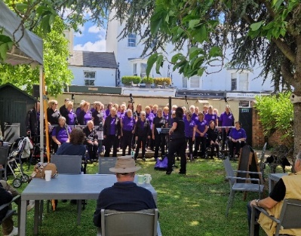 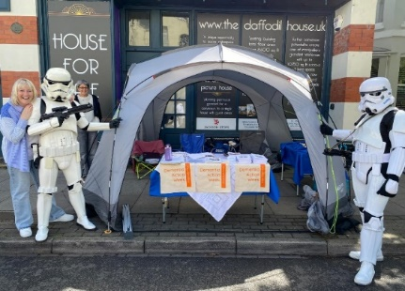 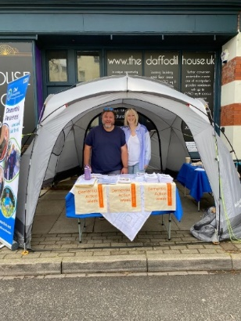r!
COMMON THEMES ACROSS THE WEEK
- Understanding and identifying themselves as a carer is a challenge – understanding what is meant by being a carer
- Unaware of IES Support within MMT – they say they weren’t offered it post diagnosis
- Professionals not knowing what MMT actually does – both within the GHC and out – not knowing that they refer back in to the service
- Care Home Challenges – reluctance in sharing care plans and information – awkward re PoAs and RESPECT – concerns re care being provided
- Denial / Anosognosia - How to get someone to recognise they have memory problems
- Growing Number of out of County Family and Carers
- Driving – the many challenges
- People don’t necessarily WANT support there and then, but NEED to know HOW to access any support there is WHEN they do need it.
- YOD – lack of services – lack of support
- Worried about own memory
- How to get someone to go the GP when they don’t recognise a “problem”, or “want” to go
- Hospital admissions – poor experiences – informed of Asma – it would appear some staff are unaware of Asma and her role – Paramedics needing to know?

GENERAL THINGS TO ENSURE GOING FORWARD
- When someone volunteers to support – we very much rely on them being there between the times they have offered as may have declined other offers of help to manage people on the stands
  - I am aware of people who put their name down to support all day, only popping in to say Hi and then leaving
  - I am also aware of people who put their name down to support not turn up, and not let us know they weren’t coming
  - I am also aware of those who put their name down to support all day not turn up until an hour before pack away
- On the flip side – where there are lots of volunteers who are staggered we need to be mindful of volunteer -v- public ratio – we had feedback that one area felt overwhelming with professionals that they did not engage until one volunteer saw them “loitering”, and approached her.
- When a volunteer is asked to help with “set up” and / or “pack away”, they are there on time, and stay to help with this (this was blue bus specific)
- Not to be used by volunteers to promote their own businesses/services alone
- All volunteers must be aware of the resources, and only have these on the table
- It is volunteers responsibilities to be aware of the themes and to have conversations around these
- It is volunteers responsibility to know about the “main services”, and what they do
- If a volunteer is dealing with someone and they do not have the knowledge, but there is someone there who does, introduce them.

Post DAW meeting help 16/07/25
Feedback / discussion on DAW:
- Busy + good week
- Venues / weather impacted foot fall
- Cirencester Cattle Market quiet all day, but 3 very good conversations (people came especially)
- Discussed what’s most important, foot fall or quality conversations? Combination of both, although support delivered is what is most important.
- Some of the public thought Blue Bus was somewhere you could get physical health checks completed
- Too many volunteers at times at some venues
- Some locations, footfall was very poor, but there was an opportunity for services to connect and build relationships
- Having a confidential space was helpful (Blue Bus)
- Needs better advertising – through local businesses, our networks and through word of mouth. Social media does not suit everyone.
- Suggested that we target GP surgeries to get comms out next time (this is working very well with our Dementia Action Days)
- Social media not as effective this year, not many likes / shares
- Should look at advertising at local businesses including Banks. Nicki, offered to be link for Barclays Bank.
- Visibility on the day important, so we get people who are walking by, but also somewhere high profile where the public pass or easy to get to.
- Banner-"come + chat to us" helpful, agreed we need more banners
- Materials/Resources need to be shared earlier with volunteers, so they know what will be available and have time to review this in preparation for DAW.
- Clear message for all, when volunteering on our ICS dementia stand, we are there to promote DAW / leaflets agreed, and not just our own organisation / business.
- We shall review volunteer guidance in preparation for next year and include message, “you are there to promote all services, and not just your own”; joint table, joint messaging.
- We shall offer volunteer MST drop-in sessions in the lead up to DAW next year.
- There were some volunteers who did not attend / support at the agreed time, or for the agreed length of time. We appreciate people are busy, but we do rely on what people have agreed to support for breaks etc. Equally, stay for your agreed time and not over, as likely other people will arrive to support, and we don’t want the stands overloaded!
- Main theme from conversations; people not understanding or recognising they are a carer and the need for carers support
- Organised events worked well, Gloucestershire Music Academy as an example of amazing work
- Rural areas? consideration for access and travel
- Locality DAA leading local events worked very well. We shall invite the chairs of the locality DAA to be part of the ICS DAW steering group
- Possible locality for 2026, Heritage Hub in Gloucestershire
- SSK to set meeting dates + start November (Wednesdays seemed to work well)
- Comms input sooner needed for 2026
- Farmers Market worked ok
- Funding / money = Need to consider options
- Social media – all partners to share social media posts in the lead up to, and during DAW.

Overall, a successful week with lots of people engaged with and opportunities for different organisations / partners to work alongside together and build relationships. Thank you to everyone who supported the planning and organising of the week, but to you all for all your support you gave during the week. Absolutely fantastic – thank you.

Volunteer feedback on common themes following engagement with public:

Q1. Was the information provided in the lead up to the week useful? could we have done anything differently?
Information was clear and timely – Vicki
Yes, thank you and no, not that I can think of. – Sophie
Attendance at Stroud Market on 17th May was very enlightening. - John
Could have been advertised more locally and also Nationally – ie Radio 2 - Kathy
Very useful, especially parking options, maps and the equipment that I would need. I did struggle to find the car park attached to the venue but easily found the other options mentioned - SP
All good – Velda
Q2. How did the day/session go you supported?
It was good from a professional networking perspective, but poorly attended by members of the public – Vicki
The Mindsong sessions were lovely with plenty of chance to chat at the end; the GAM day was very busy, full of great conversations; and the Suffolks’ Market was also busy, with lots of public interaction – Sophie
Our main event was the inaugural meeting of the Stroud Dementia Action Alliance which was described as a fantastic meeting and received a good press write up by our MP – John
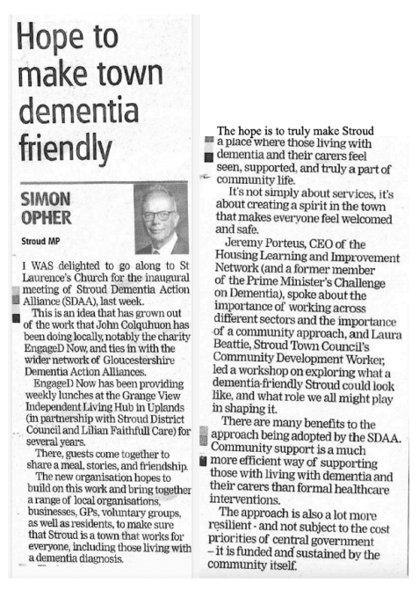

The day went and was supported by community and NHS Consultant - Kathy
It went very well, the organisation was excellent, it had clearly been well advertised as there were a lot of people there and a good variety of services in attendance. There was also a wonderful speaker and choir for information and entertainment – SP
Quiet market day so some small foot fall – Velda
Q3. What was the venue like?
Good venue, although more of the venue could have been devoted to the event that day – Vicki
All good (although a little windy at the street fair!) – Sophie
We used St Laurence’s Church in town centre which was an excellent venue.- John
The local Co-op store discount day for the elderly and table display - Kathy
Beautiful and good for the occasion – SP
Cirencester Agricultural Market - Velda
Q4. Were there any common themes of conversations/any feedback from the public?
As per above – little public attendance – Vicki
Where to go for support.
How to get a parent to the GP for an initial appointment and onward referral. - Sophie
On 17th May in the Market 2 passers by spoke of the partner with similar issues – clearly having some potential issues that they did not wish to address, not wishing to seek help and not wishing to go out and mix with other people – John
Information available. Some wanted to donate monies, others happy to have information - Kathy
Mainly, I was asked about what is available for people with/waiting for a diagnosis of dementia and also people talking about difficulties accessing social care - SP
Q5. Anything we should do differently next year?
Focusing public engagement at events already likely to have good footfall (this is already done) and perhaps focus on professional networking at other/smaller venues or link the engagement to a specific event – film showing, activity etc – again this was done at other venues this year - Vicki
Not from my point of view – Sophie
No – John
Not sure – aware can be emotive subject to some members of public - Kathy
No, it was great – SP
Better spot for foot fall- mail shot thro local NFU of date and location – Velda
Q6. Any other comments/feedback
Another successful DAW – always a delight to be involved! - Sophie
Possibly need to destigmatise the condition and raise profile - Kathy
Q7. Please indicate if you would like to be involved in the planning/organising of DAW 2026?
Yes - Vicki
Yes - Sophie
Yes - John
Yes - Kathy
No – SP
No – Velda
Q8. Please indicate if you would like to volunteer as part of DAW 2026?
Yes - Vicki
Yes - Sophie
Yes - John
Yes - Kathy
No – SP
Yes – Velda
Q9. Please indicate if you would like to be involved in any other dementia events in 2025/2026?
Yes - Vicki
Yes - Sophie
Yes - Kathy
Yes - SP
Yes - Velda

Event Feedback from DAW steering group
Q1. Planning Meetings:
Was the length of time we had to plan for DAW adequate? (First meeting was in January 2025 and DAW was in May). Please also comment on frequency of meeting and meeting length. Could we do anything differently / better next time?
Sensible to start planning in January 1 to 1.5 hour meetings good length – could we reduce to monthly? – Sally
I believe so and happy with the meeting frequency – Sophie
All good - Amy
I think timings were fine but I’m sorry I was unable to attend about half of them because of working full time and clashes with commitments at work.
Length was OK for the meetings (although 45 mins might speed them up!) - Jackie
Q2. Theme
Was enough done on and around the theme in the planning stages and during DAW itself? Any ideas for theme for next year? Could we do anything differently / better next time?
Email out before first meeting for theme ideas in order to digest and then agree at first meeting. Could the theme be led by the outcomes of the survey? - Sally
Thought it was a good theme, and the daily videos were nice around the pillars. Having the different focus each day was a nice idea, but maybe one big theme is easier to manage throughout just a short week? – Sophie
This years theme was really good - Amy
Start thinking about themes earlier, or keep ideas flowing all year. Stock pile theme ideas for future years - Jackie
Q3. Localities
We allocated leads for localities and / or the locality DAA took a lead – did this work well in the planning stages? Were any areas not covered? Do you have any suggestions for localities / place we could target next time? Could we do anything differently / better next time?
I think the GL DAA event was a good example of the DAA taking the lead works as a good model – Sally
If the Leads/DAA chairs didn’t manage to make a meeting, the minutes were comprehensive enough for follow-up. I’m not sure whether all the DAAs were represented sufficiently at the meetings, as I’m not sure who they all are, but it was good to see my CDAA Chair Jackie, regularly attend the meetings! - Sophie
More research/conversations should be had on the location of a venue to ensure that people are able to get there without difficulty and that there is enough general public footfall. I don’t know if we should use rely people attending venues solely for information on Dementia. If a location is more rural, could we look at providing transport for people? - Amy
Yes, planning was fine.
It will be useful to see the stats for people who engaged with the bus, stalls, etc., across the week.

The Suffolk Market (Cheltenham) was a busy location and had the advantage of being on a Bank Holiday Sunday. Should have been popular, but difficult for me, personally, to compare with the other locations during the week.

Always useful to link it with existing activities that are likely to be attracting many people, anyway (Pride sometimes coincides with DAW and so is useful to piggyback on that – Jackie
Q4. Anything we should do differently next time?
Not that I can think of. – Sophie
Have evenings been tried (linking with an evening event happening during DAW)? – Jackie
Q5. Any other comments/feedback
Just again, such an important week to be part of – always something to look forward to and looking forward to next year! - Sophie
Well done team! – Jackie
Q6. Please indicate if you would like to be involved in the planning/organising of DAW 2026?
Yes – Sally
Yes – Sophie
Yes – Amy
Yes – Jackie
Q7. Please indicate if you would like to volunteer as part of DAW 2026?
Yes – Sally
Yes – Sophie
Yes – Amy
Yes – Jackie
Q8. Please indicate if you would like to be involved in any other dementia events in 2025/2026?
Yes – Sally
Yes – Sophie
Yes – Amy
Yes, will be through the CDAA - Jackie

Appendix 1
 | Events in Dementia Action Week
Monday 19th | 10.30 | George Moore Centre, Bourton – Mindsong Sing to remember session
 | 13.30 | Newent Library
Entrance at Resource Centre, Alfred Street, Gloucester – display by Gloucester Art Group
(2 weeks)
Tuesday 20th | 09.00 | Cirencester Livestock Market
 | 10.30 | Pavilion in the Park, Stroud - Mindsong
 | 11.00 | St Nicholas Church Hall, Cheltenham - Mindsong
 | 11.00 | Keepers Community Hub, Wotton - Mindsong
Wednesday 21st | 09.00 | Tewkesbury Market
 | 10.30 | Hucclecote Methodise Church - Mindsong
 | 10.30 | The Oasis, Baptist Church, Chipping Sodbury - Mindsong
 | 14.00 | GL11 Community Hub, Cam
Thursday 22nd | 10.00 | Gloucester Academy of Music
 | 10.00 | Orchard Trust, Lydbrook
 | 14.00 | Together in Music, Charter Court, Gloucester
Friday 23rd | 09.00 | Gloucester Farmers Market
 | 13.30 | Churchdown Methodist Hall - Mindsong
 | 15.00 | Arkell Community Centre, Nailsworth – showing the film Oklahoma
Saturday 24th | 14.00 | Stroud Library
Sunday 25th | 11.00 | Suffolks Sunday Market, Cheltenham

